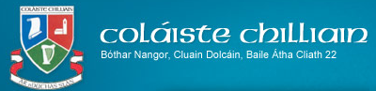
Nuachtlitir na Samhna 2021

Fáilte chuig Nuachtlitir na Samhna 2021. San eagrán seo tabharfaimid blas don saol scoile ó thosaigh an téarma ag deireadh mí Lúnasa. Welcome to the Halloween Newsletter. In this edition we will give you a taste of school life since we returned at the end of August.
Oíche Fáilte / Welcome Evening - 27ú Meán Fómhair 2021
Chuireamar fáilte oifigiúil lenár 88 dalta sa chéad bhliain ar an 27ú Meán Fómhair le hOíche Fáilte ar Google Classroom. Bhí searmanas gairid againn agus léigh daltaí agus múinteoirí roinnt léachtanna agus paidreacha ag guí gach rath ar a saol scoile anseo i gColáiste Chilliain. Labhair Eva Murray ar son Cairde Chilliain agus thug an Ceann Bliana, Daithí Ó Máirtín achoimre ar na nósanna agus rialacha is tábhachtaí. Cuireadh na múinteoirí ranga don 4 rang (Cuilinn, Fuinseoige, Darach & Sailí) in aithne freisin. Rinne an Príomhoide cur síos ar conas a oibríonn VSWare.
We officially welcomed our 88 first years on the 27th of September with our Welcome Evening’ on Google Classroom. We had a short ceremony, where pupils and teachers read readings and prayers for a successful tenure in Coláiste Chilliain. Eva Murray, as chairperson of Cairde Chilliain spoke about their role and Daithí Ó Máirtín, the Year Head spoke about the most important issues and rules for 1st years. The class teachers of the 4 classes (Cuilinn, Darach, Fuinseoige & Sailí) were also introduced. The principal made a presentation on VSWare.
Scoláireachtaí Bhronn Cairde Chilliain dhá scoláireacht ar luach €500 an ceann ar bheirt dhalta séú bliana 2020-2021. Bronntar scoláireacht €500 ar Scothscoláire na Bliana a roghnaíonn na múinteoirí agus bronntar an scoláireacht €500 eile ar an dalta a ghnóthaíonn na pointí is airde san Ardteist.
Cairde Chilliain (The Parents’ Council) award 2 scholarships to the 6th year group, worth €500 each. The first scholarship is awarded to the Student of the Year, chosen by the teaching staff and the second is awarded to the pupil who receives the highest points. The winners from the 2020-2021 6th years are as follows;
Kirsten Nic Gamhna – Scothscoláire/Student of the Year - Innealtóireacht i UCD – engineering in UCD
Saoirse Ní Dheoráin – Pointí is airde/Highest points -Innealtóireacht i gCol.na Trionóide – engineering in Trinity College.

Spórt
Peil Gaelach na gCailíní / Girls Gaelic Football
Chaill an fhoireann f/16 an dhá cluiche a bhí acu. The team lost their first two matches
Col Chilliain V Gaelcholáiste an Phiarsaigh: 4.7 – 8.12
Col Chilliain V Manor House Raheny: 5.7 – 6.7
Tá cluiche amháin eile sa ghrúpa acu tar éis an sos lár-théarma. They have one more game in the group after the midterm.

Bhuaigh an fhoireann f/20 an dhá cluiche a bhí acu agus anois tá ceathrú ceannais acu tar éis an sos lár-théarma. Bhuaigh siad an cluiche in aghaidh Edmond Rice College 2.4- 0.1 agus an dara cluiche in aghaidh Grange Community College 4.4-2.0.

The <20 team have won their first two matches and are now in a quarter final after the midterm. They beat Edmund Rice College 2-4 to 0-1 and Grange Community College 4-4 to 2-0.

Bhuaigh an fhoireann Peil Gaelach f/14 (buachaillí) an dá chluiche a bhí acu i Blitz roimh an sos lár-théarma. Bhuadar an dá cluiche go héasca agus anois tá said ag dul ar aghaidh chuig an comórtas ceart.
Col. Chilliain 7-5 Tallaght CC. 2-2
Col. Chilliain 7-7 Kishoge CC. 0-7

The u/14 boys Gaelic Football team easily won their two matches in their Blitz, organised just before the midterm. They now proceed from the group into the knockout stages.
Bainisteoir: Páidí Swinburne

Bhí cluiche amháin ag an bhfoireann Sacair f/19 bhuamar 11-0 i gcoinne St. Aidan’s CS. We won our one match so far with the u/19 soccer team 11-0 against St. Aidan’s Cs.
Bainisteoir: Ciarán Ó Cearnaigh
Bhuaigh an fhoireann iománaíochta f/16 a céad cluiche 12-12 – 3-09 V Confey College. Tá an dara cluiche acu ar an 5/11/21. Our u/16 hurling team won their first match 12-12 – 3-09 against Confey College. Their second match is on the 5/11/21.
Bainisteoir: Fiach Mac Conmara
Bhí comhscór ag an bhfoireann camógaiochta f/19 I gcoinne Loreto Crumlin 2-7 - 1-10. The u/19 camogie team played a draw against Loreto Crumlin 2-7 - 1-10.
Bainisteoir: Páidí Swinburne

Tá Aisling Ní Mhurchú ag coordniú na comórtais cispheile do bhuachailli agus cailíní. Tá fearas nua ceannaithe agus tá said ag súil na comórtais a thosú go luath.
Aisling Ní Mhurchú is coordinating the basketball competition for both boys and girls. They have purchased new gear and hope to start their league soon.

Díospóireacht/Debating
Comórtas Díospóireachta Uí Chadhain 2021
Ghlac dalta amháin ó Bhliain 6 agus beirt dhaltaí ó Bhliain a 5 páirt ar an bhfoireann sinsearach i gComórtas Díospóireachta Uí Chadhain, comórtas na nGaelcholáistí, i mbliana.
I mbabhta a haon, thug Captaen na foirne, Naomi Ní Leannáin, agus a comhghleacaithe Leona Ní Uirlithe agus Niamh Nic Risteard an-dúshlán don fhreasúra; Coláiste Íosagáin, Gaelcholáiste an Phiarsaigh agus Coláiste de hÍde. Labhair siad go muiníneach agus go hinchreidte i bhfabhar an rúin: ‘Tá drochthionchar ag na meáin shóisialta ar an tsochaí’. Cé gurb é seo an chéad uair do bheirt de na daltaí seo a bheith páirteach sa chomórtas, níor chuir sé sin aon bhac orthu. Chinntigh an t-ullmhúchán a bhí déanta acu chomh maith lena a n-argóintí ciallmhara agus paiseanta gur thuill siad áit i mbabhta a dó gan stró!
Tá súil again anois go mairfidh an paisean sin agus a ndíograis damánta nuair a thabharfaidh siad aghaidh ar bhabhta dó i gceann míosa. Guímid gach ádh agus rath orthu
One pupil from 6th year and two from 5th year took part in the Comórtas Uí Chadhain senior debating competition for Gaelcholáistí this year.
In the first round our captain Naomi Ní Leannáin and her teammates Leona Ní Uirlithe and Niamh Nic Risteard challenged the opposing teams Coláiste Íosagáin, Gaelcholáiste an Phiarsaigh and Coláiste de hÍde with the motion that, ‘Social media has a negative influence on society’. They presented credible and confident arguments in favour of the motion. Although, for two of our team this was their first outing on a debating team, they acquitted themselves well, due to their preparation and convincing points and for these reasons truly deserved to get through to the second round – congrats!!! The second round will be in November and we wish them every success.

Gaeilge 24
Tá Coláiste Chilliain ar cheann de 300 scoil sa tír atá cláraithe chun páirt a ghlacadh i nGaeilge 24, a bheidh ar siúl ar an 9ú lá de Shamhain arís i mbliana. Go dtí seo, chláraigh os cionn 100 duine ón scoil, idir mhúinteoirí agus dhaltaí, chun páirt a ghlacadh sa dúshlán.
Is í an aidhm atá leis an imeacht spraoiúil seo ná daoine a spreagadh chun an teanga a labhairt ar feadh an lae, ní hamháin sa scoil ach sa bhaile freisin agus amuigh i measc an phobail. Caitheann na daltaí t-léinte le ‘Labhair Gaeilge Liom Inniu’ scríofa orthu agus bíonn píosa craic acu agus iad ag déanamh iarrachta gan focal Béarla a labhairt ar an lá.
I mbliana, tá sé i gceist againn an ócáid a a dhéanamh beagánín níos spraoiúla de bharr go bhfuil ár scoil ag ceiliúradh daichead bliain ar an bhfód. Is é an plean atá againn ná tús a chur leis an lá le bricfeasta blasta, a bheidh ullmhaithe ag Aoife Ní Dheisigh, a chur ar fáil do na daltaí. Tar éis am sosa, beidh Tráth na gCeist ar siúl agus duaiseanna beaga le buachan. i ndiaidh am lóin, íoga trí Ghaeilge sa seomra mór a bheidh ar an gclár. Ansin ar deireadh thiar, d’eagraigh Meadhbh Ní Cheallaigh turas chuig Áras Chrónáin dóibh siúd a bhfuil fonn orthu fanacht ar scoil cúpla uair an chloig eile chun an dúshlán a chomhlíonadh. Beidh deis ag na daltaí breathnú ar scannán Gaeilge ansin agus a scíth a ligint ar feadh tamall beag.
Tá muid ag súil go mór leis an lá agus bródúil go mbíonn ár ndaltaí sásta páirt a ghlacadh sa dúshlán seo bliain i ndiaidh bliana.
Coláiste Chilliain is one of 300 schools registered to take part in Gaeilge 24, which will happen on November 9th. Up until now over 100 pupils and teachers have registered to undertake this challenge, to speak only Irish for 24 hours.
The aim is to have fun while encouraging others, not only in school, but also at home or in the community to use whatever Irish they have. They will be wearing red t-shirts, with the sentence ‘Labhair Gaeilge Liom Inniu’ written on it.
This year, to celebrate Coláiste Chilliain’s 40th birthday we aim to make it a little more fun. We plan to start the day with a breakfast, organised by Aoife Ní Dhéisigh, the Home Economics teacher. After small break we will have a table quiz, with some prizes to be won. After lunch we will have Yoga ‘as Gaeilge’ and for those who would like to stay after school Meadhbh Ní Cheallaigh has organised a trip to Áras Chrónáin where films as Gaeilge will be shown. This will help fulfilling some of the 24 hours.
We are really looking forward to the day and we are very proud of our pupils, who are willing to participate year in year out.

Comórtas Labhairt na Gaeilge
Tá ‘Comórtas Labhairt na Gaeilge’ faoi lán seoil i gColáiste Chilliain faoi láthair agus a bhuíochas sin de Chomhairle na nDaltaí.
Is iomaí cruinniú a bhí ag an gComhairle chun teacht aníos le plean a spreagfadh na daltaí chun an Ghaeilge a labhairt agus Béarla a sheachaint. D’oibrigh siad go dian dícheallach agus sa deireadh is é seo a bheartaigh siad; comórtas a mhairfeadh sé seachtaine, barrachairt crochta sa bhialann a léireodh dul chun cinn na ranganna éagsúla ar bhonn seachtainúil agus turas chuig an bpictiúrlann don rang a bhuafadh.
Anois agus seachtain a dó den chomórtas beagnach críochnaithe, tá an t-iomaíochas idir na ranganna le braith go cinnte. Tá seanfhocail á gcaitheamh thart, tá daltaí ag ceartú na Gaeilge dá chéile agus tá dánta áille á scríobh do mhúinteoirí, rud ar bith a thuillfeadh cúpla pointe sa bhreis do rang!
‘Tús maith leath na hoibre’ a deirtear agus is cinnte go bhfuil tús maith curtha i mbliana ag Comhairle na nDaltaí le spreagadh na teanga i gColáiste Chilliain.
Comórtas Labhairt na Gaeilge (speaking Irish competition) is in full swing now thanks to the Student Council (Comhairle na nDaltaí).
This competition is the product of many council meetings where the topic was how to encourage Irish and avoid English. They worked hard on coming up with a plan and eventually decided on a 6 week competition, where the classes would be awarded points, shown on a huge barchart in the canteen for the various activities related to the spoken language. The prize is a class trip to the cinema.
After just 2 weeks of competition we can certainly feel the competitive atmosphere, with pupils using ‘seanfhocail’, correcting each other’s’ Irish, writing poems etc. – anything to gain extra points for their class.
Tús maith leath na hoibre as the old saying goes and there is no doubt that the Student Council has made an excellent start in promoting the language in the school!
Gluais
D’eagraigh Maebh Ní Chléirigh go bhfaighfeadh daltaí na 5ú bliana le suim traenáil mar chinnirí scoile I rith mí Meán Fómhair/Deireadh Fómhair. Gluais is ainm don eagraíocht a chuireann an traenáil ar fáil agus i mbliana tharla sé ar líne thar deireadh seachtaine. Tharla an traenáil tar éis próiséas iarratais agus agallaimh. Is mór an iarracht a rinne na daltaí sa traenáil seo agus molaimid go mór iad. De ghnáth tharlódh an traenáil san Idirbhliain ach de bharr Covid ní raibh sé ar fail. Tá said tosaithe cheana féin ag gníomhú sa scoil, ag díriú ar bhliain a haon ach go háirithe. Bíonn tionscnamh le déanamh acu agus bíonn orthu tuairisc a chur ar fail do Ghluais ag deireadh na bliana.
Maebh Ní Chléirigh organised, that interested 5th year students would receive Leadership training from an organisation called ‘Gluais’ during September/October. The main training happened over a weekend, online and we are very impressed with the effort put in by pupils to complete this training. The process included applying and being interviewed before being accepted on the training course. Usually this would happen in TY but due to Covid this couldn’t happen.
Is iad na Cinnirí ná / The Prefects are:
Sadhbh Ní Chaoimh
Niamh Nic Risteard
Áine Ní Fhearghaíl
Ella Nic Dháibhéid
Emma Ní Ghallchóir

Turais –Trips
Tá dhá 2 thuras thar lear eagraithe don scoilbhliain seo. Two trips abroad have been organised this school year
Gealladh, de bharr covid anuraidh go mbeadh deis ag daltaí na 5ú bliana dul ar thuras agus tá sé sin eagraithe ag Maebh Ní Cléirigh. Beimid ag dul chuig Ehrwald san Ostair ar feadh seachtaine – seachtain Lá ‘le Pádraig. Beimid ag scíáil don tseachtain.
We promised the current 5th year that we would go on a foreign trip to make up for their disrupted TY. Maebh Ní Chléirigh undertook to organise a skiing trip to Ehrwald, in Austria during the week of St. Patrick’s Day.

Tá Alsún Ní Bhrannagáin ag eagrú turas chuig Páras do dhaltaí na hIdirbhliana don Chásc seo chugainn. Tá na sonraí nach mór réidh agus dáilfear iad nuair atá an pacáiste go léir réidh.  Alsún Ni Bhrannagáin has also nearly finalised a TY trip to Paris next Easter. The details are almost finalised and distributed soon. | 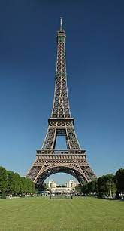

Tá Aoife Ní Shúilleabháin tar éis turas lae do bhliain 1 a eagrú chuig Kilruddery House, Brí Chualainn don 9/11/21. An t-ainm atá air ná 'Alive Outside'. Tá réimse leathan imeachtaí ar fáil idir cadhcáil, neartú foirne, scileanna maireachtála, boghdóireachta &rl.
Aoife Ní Shúilleabháin has also organised a day trip to Kiruddery House, Bray for 9/11/21. The name of the Adventure Centre is ‘Alive Outside’ and they provide a wide range of activities such as kayaking, team building, survival skills, archery etc.
Idirbhliain 2021-2022
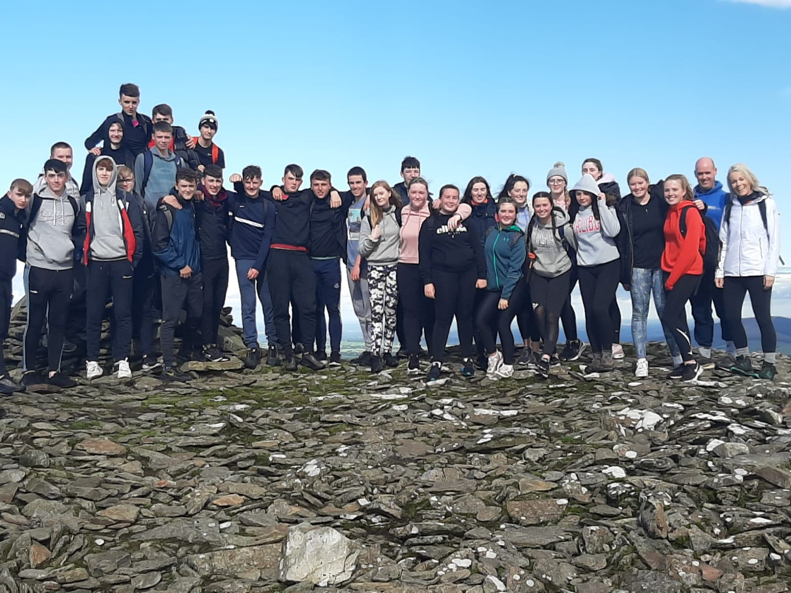 | Tá tús maith curtha leis an Idirbhliain I mbliana, don mhórchuid de bharr laghdú ar na srianta covid a bhí ann anuraidh. We have had a great start to the TY this year, mainly due to the easing of many of the Covid-19 restrictions
Tá tráthnóna Dé Máirt curtha ar leathtaobh do thurais agus eachtraíocht. Go dtí seo bhí an Idirbhliain ar thuras gach Máirt. Sa ghriangraf thuas feictear daltaí na hIdirbhliana ar bharr chnoic i mBaile Galisín i gCo. Ceatharlach in éineacht le múinteoirí Martha agus Ciarán. Tuesday afternoons are set aside for trips and workshops. Until now the TY students have been on a trip every Tuesday. In the photo above you see the pupils and teachers Ciarán and Martha on top of a mountain in Ballyglasin, Co.Carlow
Go dtí seo, chomh maith leis an dreapadóireacht tá an Idirbhliain tar éis na rudaí seo a leanas a dhéaamh. As well as mountain climbing the pupils have also done the following:
- ‘Alive Outside’: Kilruddery House, Co. Chill Mhantáin: Eachtraíocht agus scileanna saoil (athrú roth agus ag úsáid jump leads) Eventing and Life Skills
- Cuairt ar Russborough House i gCo. Chill Mhantáin
- Rinneadar Ceardlann Foiréinsice anseo sa scoil/ Forensics Workshop
- Thugadar cuairt ar an gComhdháil Idirbhliana: Taispeántas le heolas faoi imeachtaí ar fáil do dhaltaí Idirbhliana/ Visited the TY Exhibition – information regarding TY possibilities
Is iad seo na turais agus eachtraí atá eagraithe don chéad cúpla seachtain eile. The following few Tuesdays see them visiting
- An Sú do cheardlann caomhnóireachta – the Zoo for a conservation workshop
- Ceardlann Tiomána - Driving Workshop.

Aonach na Smahna / Halloween Fair
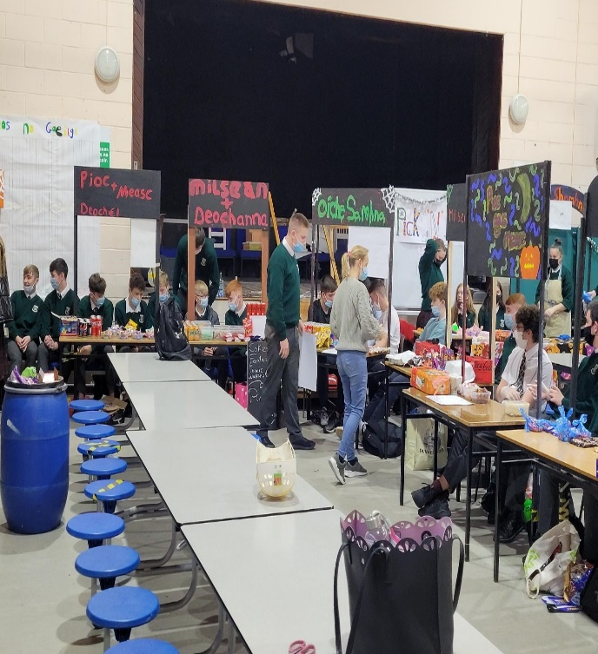 | Chomh maith leis na turais uilig, d’eagraigh daltaí na hIdirbhliana Aonach na Samhna, bunaithe ar an obair atá déanta acu sa rang Fiontair ó thús na bliana. Bhí deis ag gach rang cuairt a thabhairt ar an Aonach a bhí ar siúl sa bhialann.  Along with the trips outlined above the TY pupils organised a Halloween fair, based on the work they have been doing in their Enterprise class form the start of the year. All classes had an opportunity to visit the fair, which was held in the canteen

Tógáil
Ar deireadh tá dea-scéal againn faoin gCampus Lán-Ghaeilge anseo ar shuíomh Choláiste Chilliain.Ta conrathóir roghnaithe ag an Roinn Oideachais & Scileanna agus faomhaithe ag DDLETB/BOOACDL. Caithfear anois fanacht ar an scéal an nglacfaidh an conrathóir sin leis an tionscnamh seo. Má ghlacann táimd ag súil go mbeadh an tógáil ag tosú go luath i 2022.
Campus = Foirgneamh nua do Ghaelscoil Chluain Dolcáin agus Gaelscoil na Camóige móide Halla Spóirt nua do Choláiste Chilliain
Is é an plean freisin, achóiriú agus síneadh a chur leis an bpáirc uile aimsire in éineacht le Cumann an Chlogthí
At long last, there is some good news on the Campus Lán-Ghaeilge front here on Coláiste Chilliain’s land. The Department of Education & Skills has chosen a contractor and await a response from them regarding this project. If they accept it we expect the building to begin early in 2022.
Campus = new school buildings for Gaelscoil Chluain Dolcáin and Gaelscoil na Camóige as well as a Sports Hall for Coláiste Chilliain.
We also plan to develop the all-weather pitch in partnership with Round Towers GAA.

Obair an tSamhraidh
Déanadh roinnt mhaith obair ar an scoil i rith an tSamhraidh. Cuireadh córas iomlán nua alarum tine sa scoil a chiallaigh go raibh gach uile seomra agus cúinne sa scoil bun os cionn don Samhradh. Tá an obair déanta agus bhí an scoil nach mór curtha ar ais in ord agus eagar sular fhill na daltaí.
Chomh maith le sin déanadh péinteáil ar na seomraí 1- 10. Obair mhór a bhí ann agus iarraimid ar na daltaí na seomraí a choimeád chomh glan agus is féidir tar éis na hoibre sin.
The school’s fire alarm system was completely replaced during the Summer under the Department’s ‘Summer Works’ scheme. Every room and corner in the school was impacted but we managed to get the school 99% back in order by the time the pupils arrived back in August.
We also got rooms 1-10 painted – walls, ceilings, window sills and skirting boards. We ask all base classes to try to maintain this level of cleanliness
Comórtas Glaineachta / Cleanest Room Competition
Bhí dhá bhuaiteoir again go dtí seo don chomórtas glaineachta – is é sin na bunseomraí a choimeád chomh galn agus néata agus is féidir.Bhuaigh Bliain 1 Rang Fuinseoige (Seomra 3) an duais (lón Pizza) do Mheán Fhómhair agus bhuaigh Bliain 6, Rang Seiceamar an duais do mhí Dheireadh Fómhair. Gabhaimid comhgáirdeas leo as ucht an iarracht a dhéanamh a mbunseomraí a choimeád glan agus néata.
As the pupils now have base classroom, where they have most of their lessons, we introduced a competition to encourage them to keep these rooms neat and tidy. Points are awarded every day on the general state of the rooms. At the end of the month the room with the highest points wins.
September – 1 Fuinseoige – Seomra 3
October – 6 Seiceamar – Seomra Grafaic Theicniúla
We congratulate them on the efforts made to keep their rooms neat and tidy.

An Gáirdín Scoile
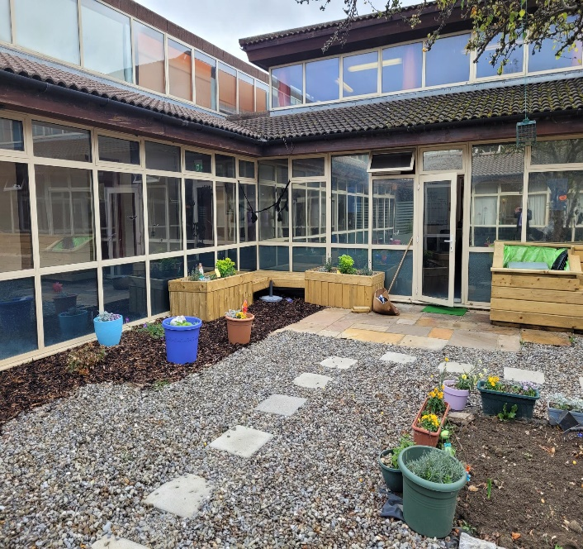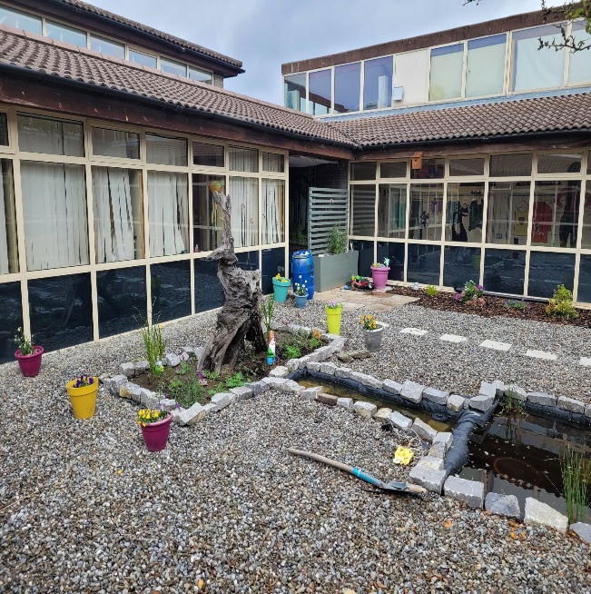
Thug foireann na scoile, Shauna Ní Choileáin & Orla Nic Shiacias ach go háirithe, in éineacht le tuismitheoirí agus daltaí scoile faoin ngáirdín scoile a athchóiriú i rith an tSamhraidh. Bhíomar ag iarraidh go mbeadh gáirdín cuimhneacháin againn a bheadh oiriúnach le hagahidh ceiliúradh 40 bliain ó buaníodh Coláiste Chilliain i 1981. Tá sár-obair déanta agus tá sé beagnach réidh.
Taobh leis an ngáirdín déanadh seomra suaimhnis do dhaltaí atá in ísle brí nó ag lorg tearmainn agus tá plean ann spás céadfach a dhéanamh ann freisin.

Seomra Suaimhnis
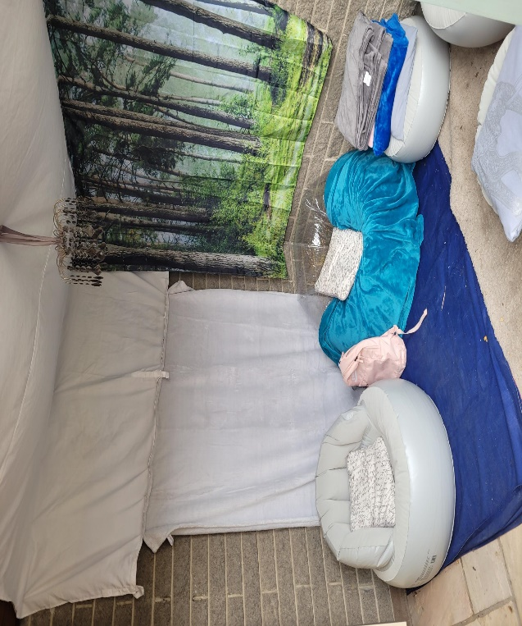
The school staff, Shauna Ní Choileáin and Orla Nic Shiacais in particular, along with parents and pupils undertook to overhaul the school garden during the Summer. We wanted the memorial garden to be in a fit state to commemorate the founding of Coláiste Chilliain 40 years ago in 1981. They have done a magnificent job and it is near completion.
To one side of the garden a ‘Quiet Area’ was constructed for pupils who need a time out or respite. It is also planned to create a sensory space on the other side.

Baill Foirne Nua
Thosaigh beirt mhúinteoir nua linn i mbliana:
Ciarán Ó Cearnaigh = Corpoideachas
Roibeárd Ó hUIrlithe = Mata & Eolaíocht.
Tá Cuntóir teangan againn freisin ón nGearmáin, Fabian Schmitz.
We welcome new staff to the school this year in PE, Maths & Science as well as a Foreign Language Assistant from Germany.

Measúnú 1
Tá measúnú 1 do bhlianta 1,2,3,5 & 6 anois ar fáil ar VS Ware. Beidh scrúduithe na Nollag ar siúl go luath freisin. Bliain 3 & 6 ar dtús agus níos déanaí blianta 1,2, & 5. Cuirfear na dátaí ar fáil go luath.
Muna bhfuil tú ábalta du lar VS Ware cuir r-phost chuig eolas@ colaistechilliian.ie.
The first assessment results are now available on VS Ware for 1st, 2ns, 3rd, 5th and 6th years. The Christmas exams will be happening soon, 3rd & 6th years first and 1st,2nd and 5th years at a later date. We will inform the pupils of the timetable soon.
If you are unable to access VSware please email eolas@colaistechilliain.ie.

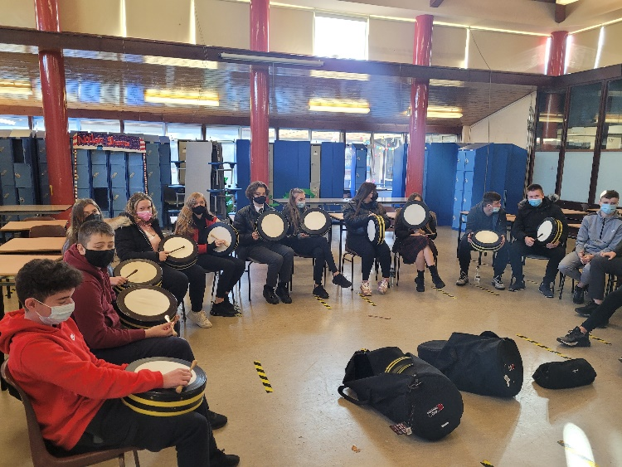
Ceol
Tá ranganna cheoil seach-churaclach tosaithe arís sa scoil, eagraithe ag Séamus Ó Riain. Tá ranganna bodhráin, giotáir tosaithe agus táimid ag iarraidh ranganna fidil agus concertina a thosú freisin.
Beidh Mairéad Nic Mhathúna ag lorg daltaí le páirt a ghlacadh sa chomórtas, ‘SCLÉIP’ a bheith ar siúl tar éis na Nollag.
We have begun extra-curricular music classes again, organised by Séamus Ó Riain. So far we have organised bodhrán and guitar classes and we hope to organise fiddle and concertina classes soon.
Mairéad Nic Mhathúna will be looking for pupils to participate in the talent show as Gaeilge, ‘SCLÉIP’ which will be happening after Christmas.

Sci-Fest & Seachtain na hEolaíochta / Science Week
Tá seachtain na hEolaíochta ar siúl an tseachtain dár tús 8/11/21. Tá iliomad eachtraí eagraithe, idir Fear na Reiptílí, Turgnaimh, Turais agus tráth na gceist.
Tá daltaí na hIdirbhliana ag glacadh páirte sa chomórtas Eolaíochta ‘Sci-Fest’ agus tá eolaíthe ag teacht isteach le moltóireacht a dhéanamh ar a gcuid tionscnaimh atá idir láimhe acu o thús na scoilbhliana.
Science week begins on 8/11/21. The science department has organised many events from Reptile Man to Science trips to Quizzes and experiments. The highlight is the TY science projects being displayed and adjudicated by visiting scientists – past pupils amongst them. The TY have been working on these projects since the start of the school year.
Imeachtaí Seachtain na hEolaíochta 2021 08/11/2021-12/11/2021
Dé Luan 08/11/2021: - Fear na Reiptíl (Bliain a 1, 2, 5 & 6) –Reptile Man!
Dé Máirt 09/11/2021: - Fear na Reiptíl (Bliain a 1, 2, 5 & 6)
Bliain a 4: Turas chuig an Zú. Cúrsa Caomhnú ar siúl. – Trip to the Zoo – conservation workshop
Dé Céadaoin 10/11/2021: - Seiminár Greasáin ‘The Science of De-extinction’ 11:00 – Web conference
- Nasc le fáil ón Roinne Eolaíochta más rud é gur mian leat é seo a chur ar siúl do do rang.
Déardaoin 11/11/2020: - Sci-Fest ar siúl sa Seomra Mór: Bliain a 4: T1-T3 –
- Bliain a 3 ag freastal ar Sci-Fest: T1-T2 (Beidh amchlár ar fáil an tseachtain seo chugainn)
- ‘Fíor-Eolaíocht Ní Bhréag-Eolaíocht’ le Daithí T3-T4 Bliain a 1 - True or False Science
Dé hAoine: 12/11/2020: - Quiz Eolaíochta sa Bhialann ag Am Sosa. Duaiseanna ar fáil!!!!
- Seastán Eolaíochta – Science Stand in canteen
- Gach lá sa Bhialann: Bí cinnte cuairt a thabhairt air.
COVID-19
Tá an-tionchar ag an bpaindéim ar shaol gach duine. Is fíor sin ar scoil chomh maith. Iarraimid ar na daltaí comhoibriú linn maidir le rialacha covid-19, go háirithe ó thaobh na mascanna a chaitheamh I gceart = thar an srón agus béal!
Tá an víreas ag cur isteach ar reachtáil na scoile sa mhéid is go bhfuil gá ag baill foirne aonarú nuair atá tástáil faighte nó nuair atá an víreas faighte acu. Ciallaíonn sé sin go mbíonn múinteoirí as láthair. Bíonn obair curtha acu dos na ranganna áfach.

The Covid-19 pandemic has affected us all. Schools have not escaped the huge impact it is having on our lives. We ask for the continued cooperation of the students in following our covid rules, especially the wearing of masks. They need to be worn properly, that is covering both mouth and nose.
The virus is affecting the administration of the school. Teachers have to isolate if they are awaiting a test result and if they test positive. This means that staff absenteeism. However, work is arranged for those classes.

